Econometrics 343 - Empirical Analysis Project

Luca Seazzu

4/14/2023

Revenue in Million Euros

## Model Fitting

### Model on the data for the year equal to or less than 2009.

model09 <- data |>  
 filter(Year <= 2009) |>  
 lm(formula = Pos ~ Income + Rank + Last_Pos + Big6, na.action = na.exclude)  
summ(model09, confint = TRUE, digits = 3)

Observations

56 (16 missing obs. deleted)

Dependent variable

Pos

Type

OLS linear regression

F(4,51)

17.530

R²

0.579

Adj. R²

0.546

Est.

2.5%

97.5%

t val.

p

(Intercept)

5.536

-0.361

11.433

1.885

0.065

Income

-0.011

-0.032

0.011

-1.000

0.322

Rank

0.128

-0.099

0.355

1.134

0.262

Last_Pos

0.316

0.045

0.587

2.344

0.023

Big6

-1.922

-4.108

0.263

-1.766

0.083

Standard errors: OLS

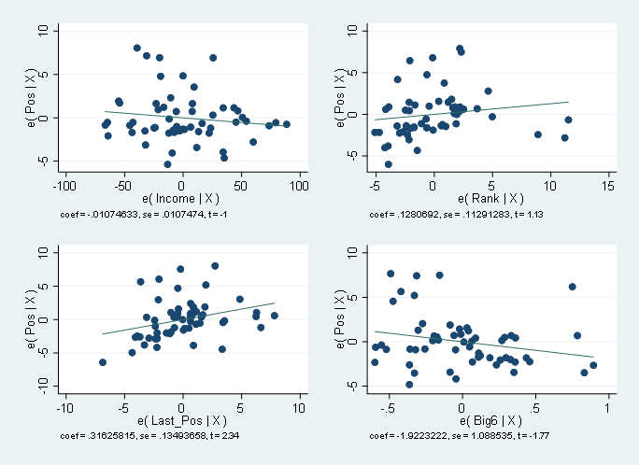

Years <= 2009

### Model on the data for the years 2010 through 2013.

model09.13 <- data |>  
 filter(Year > 2009 | Year <=2013) |>  
 lm(formula = Pos ~ Income + Rank + Last_Pos + Big6, na.action = na.exclude)  
summ(model09.13, confint = TRUE, digits = 3)

Observations

201 (33 missing obs. deleted)

Dependent variable

Pos

Type

OLS linear regression

F(4,196)

70.072

R²

0.588

Adj. R²

0.580

Est.

2.5%

97.5%

t val.

p

(Intercept)

2.937

0.740

5.135

2.636

0.009

Income

0.000

-0.003

0.004

0.097

0.923

Rank

0.207

0.113

0.300

4.359

0.000

Last_Pos

0.291

0.159

0.424

4.323

0.000

Big6

-1.790

-3.186

-0.395

-2.530

0.012

Standard errors: OLS

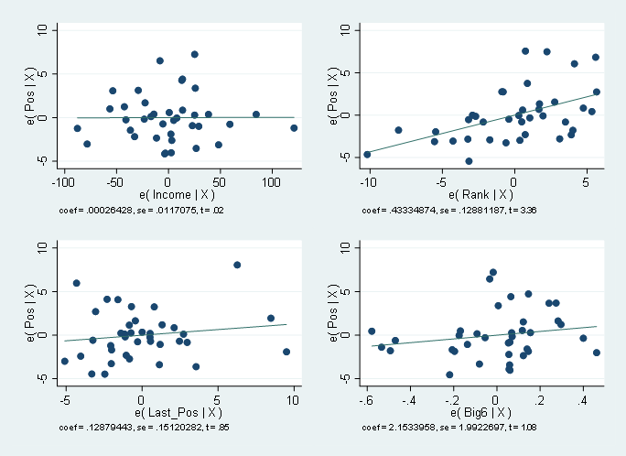

Years > 2009 and <= 2013

### Model on the data for the years greater than 2013.

model13 <- data |>  
 filter(Year > 2013) |>  
 lm(formula = Pos ~ Income + Rank + Last_Pos + Big6, na.action = na.exclude)  
summ(model13, confint = TRUE, digits = 3)

Observations

107 (15 missing obs. deleted)

Dependent variable

Pos

Type

OLS linear regression

F(4,102)

34.097

R²

0.572

Adj. R²

0.555

Est.

2.5%

97.5%

t val.

p

(Intercept)

6.739

1.482

11.996

2.543

0.013

Income

-0.006

-0.015

0.003

-1.294

0.199

Rank

0.122

-0.042

0.286

1.472

0.144

Last_Pos

0.230

0.029

0.431

2.266

0.026

Big6

-1.457

-3.861

0.947

-1.202

0.232

Standard errors: OLS

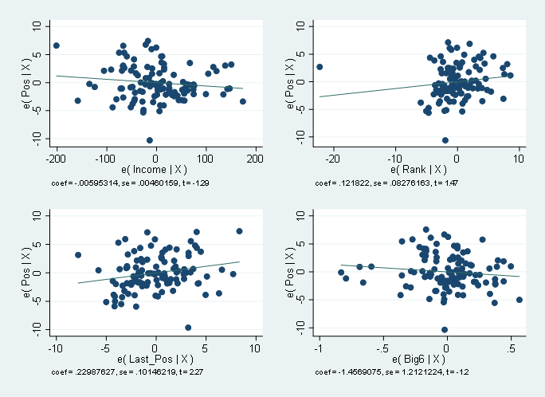

Years > 2013